**Numerical computation – Assignment 10**

**薛劭杰 1920026143**

Q1.

$m=1, 2 and 4 subintervals$ which is nonequivalence. Apply the composite Trapezoid Rule for $\int_{0}^{\frac{π}{2}}{\cos{x dx}}$:

When $m=1, h=\frac{\frac{π}{2}-0}{1}=\frac{π}{2}$

$\int_{0}^{\frac{π}{2}}{\cos{x dx}}≈\frac{h}{2}\left[f\left(0\right)+f\left(\frac{π}{2}\right)\right]=\frac{π}{4}\left(1+0\right)=\frac{π}{4}≈0.7854$

And the true value is: $\int_{0}^{\frac{π}{2}}{\cos{x dx}}=sin{x|}_{0}^{\frac{π}{2}}=1$.

$E=I-T=1-0.7854=0.2146$

When $m=2, h=\frac{\frac{π}{2}-0}{2}=\frac{π}{4}$

$\int_{0}^{\frac{π}{2}}{\cos{x dx}}≈\frac{h}{2}\left[f\left(0\right)+f\left(\frac{π}{4}\right)+f\left(\frac{π}{4}\right)+f\left(\frac{π}{2}\right)\right]=\frac{π}{8}\left(1+\frac{\sqrt{2}}{2}+\frac{\sqrt{2}}{2}+0\right)≈0.9481$

And the true value is: $\int_{0}^{\frac{π}{2}}{\cos{x dx}}=sin{x|}_{0}^{\frac{π}{2}}=1$.

$E=I-T=1-0.9481=0.0519$

When $m=4, h=\frac{\frac{π}{2}-0}{4}=\frac{π}{8}$

$\int_{0}^{\frac{π}{2}}{\cos{x dx}}≈\frac{h}{2}\left[f\left(0\right)+f\left(\frac{π}{8}\right)+f\left(\frac{π}{8}\right)+f\left(\frac{π}{4}\right)+f\left(\frac{π}{4}\right)+f\left(\frac{3π}{8}\right)+f\left(\frac{3π}{8}\right)+f\left(\frac{π}{2}\right)\right]=\frac{π}{16}\left(1+\frac{\sqrt{2+\sqrt{2}}}{2}+\frac{\sqrt{2+\sqrt{2}}}{2}+\frac{\sqrt{2}}{2}+\frac{\sqrt{2}}{2}+\frac{\sqrt{2-\sqrt{2}}}{2}+\frac{\sqrt{2-\sqrt{2}}}{2}+0\right)≈0.9871$

And the true value is: $\int_{0}^{\frac{π}{2}}{\cos{x dx}}=sin{x|}_{0}^{\frac{π}{2}}=1$.

$E=I-T=1-0.9871=0.0129$

Q2.

$\int_{2}^{3}{e^{x}dx}=e^{x}{\left.​\right|}_{2}^{3}≈12.6965$

Apply the composite Trapezoid Rule for $\int_{2}^{3}{e^{x}dx}$ with equal subintervals:

When $h=1$, $\frac{1}{2}*1*\left[f\left(2\right)+f\left(3\right)\right]≈\frac{1}{2}*27.4746=13.7373$

When $h=\frac{1}{2}$, $\frac{1}{2}*\frac{1}{2}*\left[f\left(2\right)+f\left(\frac{5}{2}\right)+f\left(\frac{5}{2}\right)+f\left(3\right)\right]≈\frac{1}{4}*(51.8396)=12.9599$.

$\left|E\right|≤|\frac{-\left(b-a\right)h^{2}}{12}*\max_{2≤x≤3}{f^{''}\left(x\right)}|$ and $\max_{2≤x≤3}{f^{''}(x)}=\max_{2≤x≤3}e^{x}=e^{3}≈20.0855$

$\left|E\right|≤\frac{3-2}{12n^{2}}e^{3}≤{10}^{-3}, n^{2}≥1,673.7916→n≥40.9120→n≥41$

Q3.

When $m=2,h=\frac{π-0}{2}$

$\int_{0}^{π}{x cosxdx}≈\frac{h}{3}\left[f\left(x_{0}\right)+4\sum_{i=1,3,5…}^{n-1}{f\left(x_{i}\right)}+2\sum_{i=2,4,6…}^{n-2}{f\left(x_{j}\right)}+f\left(n\right)\right]=\frac{π}{6}\left[f\left(0\right)+4f\left(\frac{π}{2}\right)+f\left(π\right)\right]=\frac{π}{6}*(0+0-π)=-1.6449$

$\int_{0}^{π}{x\cos{x}dx}={xsinx|}_{0}^{π}-\int_{0}^{π}{sinx dx}=\cos{π}-\cos{0}=-2$

$E=I-T=-2+\frac{π^{2}}{6}=-0.3551$

When $m=4,h=\frac{π-0}{4}$

$\int_{0}^{π}{x cosxdx}≈\frac{h}{3}\left[f\left(x_{0}\right)+4\sum_{i=1,3,5…}^{n-1}{f\left(x_{i}\right)}+2\sum_{i=2,4,6…}^{n-2}{f\left(x_{j}\right)}+f\left(n\right)\right]=\frac{π}{6}\left[f\left(0\right)+4\left(f\left(\frac{π}{4}\right)+f\left(\frac{3π}{4}\right)\right)+2f\left(\frac{π}{2}\right)+f\left(π\right)\right]=\frac{π}{12}*\left(-1-\sqrt{2}\right)π=-1.9856$

$\int_{0}^{π}{x\cos{x}dx}={xsinx|}_{0}^{π}-\int_{0}^{π}{sinx dx}=\cos{π}-\cos{0}=-2$

$E=I-T=-2+\frac{π^{2}}{6}=-0.0144$

$m=8,h=\frac{π}{8},x_{0}=0$

$\int_{0}^{π}{x cosxdx}≈\frac{h}{3}\left[f\left(x_{0}\right)+4\sum_{i=1,3,5…}^{n-1}{f\left(x_{i}\right)}+2\sum_{i=2,4,6…}^{n-2}{f\left(x_{j}\right)}+f\left(n\right)\right]=\frac{π}{24}\left[f\left(0\right)+4\left(f\left(\frac{π}{8}\right)+f\left(\frac{3π}{8}\right)+f\left(\frac{5π}{8}\right)+f\left(\frac{7π}{8}\right)\right)+2\left(f\left(\frac{π}{4}\right)+f\left(\frac{π}{2}\right)+f\left(\frac{3π}{4}\right)\right)+f\left(π\right)\right]=\frac{π}{24}*\left(-π-4\left(\frac{π}{8}\cos\left(\frac{π}{8}\right)+\frac{3π}{8}\cos\left(\frac{3π}{8}\right)+\frac{5π}{8}\cos\left(\frac{5π}{8}\right)+\frac{7π}{8}\right)+2\left(\frac{π}{4}\cos\left(\frac{π}{4}\right)+\frac{π}{2}\cos\left(\frac{π}{2}\right)+\frac{3π}{4}\cos\left(\frac{3π}{4}\right)\right)\right)≈ -1.9992$

$\int_{0}^{π}{x\cos{x}dx}={xsinx|}_{0}^{π}-\int_{0}^{π}{sinx dx}=\cos{π}-\cos{0}=-2$

$E=I-T=-2-\left(-1.9992\right)=-0.0008$

Q4.

Using the Trapezoidal Rule $→m=0$, when $n=1→h=4$

$R\left(0,0\right)=\frac{h}{2}\left[f\left(1\right)+f\left(5\right)\right]=2\left(2.4142+3.2804\right)=11.3892$

When $n=2→h=2$:

$R\left(1,0\right)=\frac{h}{2}\left[f\left(1\right)+f\left(3\right)+f\left(3\right)+f\left(5\right)\right]=\left(2.4142+2.8974*2+3.2804\right)=11.4894$

When $n=4→h=1$:

$R\left(2,0\right)=\frac{h}{2}\left[f\left(1\right)+f\left(2\right)+f\left(2\right)+f\left(3\right)+f\left(3\right)+f\left(4\right)+f\left(4\right)+f\left(5\right)\right]=\left(2.4142+2*2.6734+2.8974*2+2*3.0976+3.2804\right)=11.5157$

Using Simpson’s Rule $→m=1$, when $h=2,$ we have $x_{0},x_{2},x_{4}$

$R(1,1)=\frac{1}{3}\left[f\left(1\right)+f\left(5\right)+4\left(f\left(2\right)+f\left(4\right)\right)+2\left(f\left(3\right)\right)\right]=11.5245$

$R\left(2,1\right)=\frac{2}{3}\left[f\left(1\right)+f\left(5\right)+4\left(f\left(3\right)\right)\right]=11.5228$

$R\left(2,2\right)=\frac{4^{2}R\left(2,1\right)-R\left(1,1\right)}{4^{2}-1}=11.5246$

The most accurate value of $\int_{1}^{5}{f\left(x\right) dx}$ is $11.5246$.

Q5.

The function code is:

$f=x e^{2x}, a=0 and b=4, n is the shape$

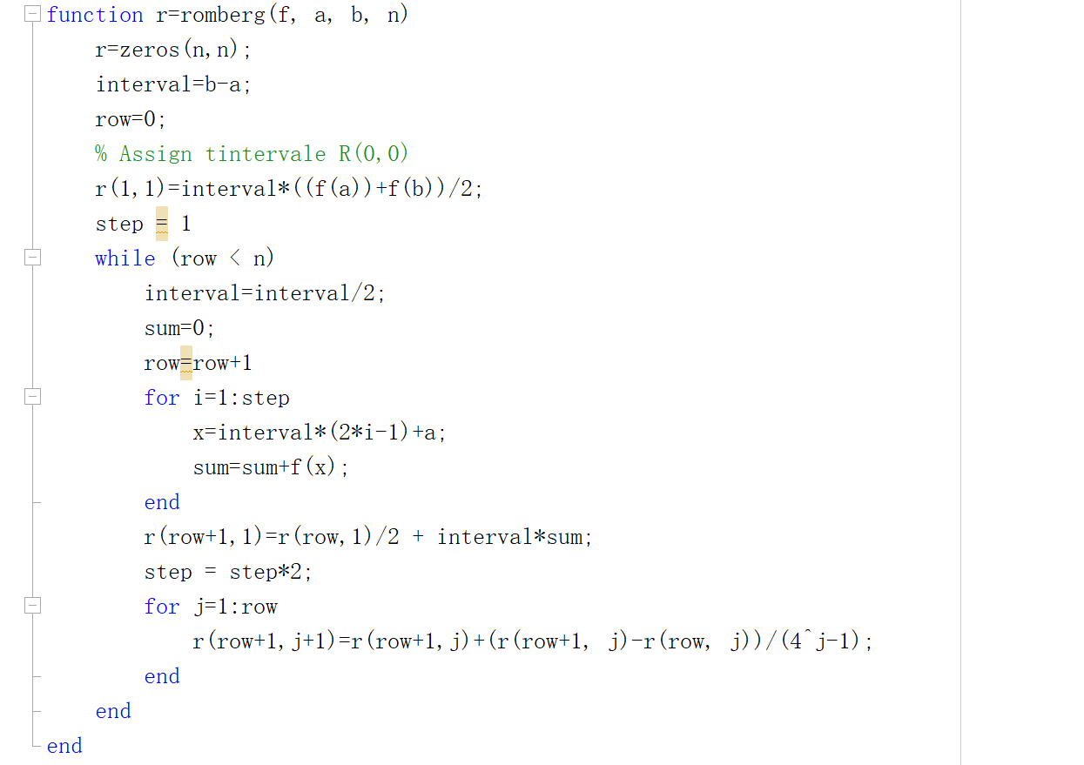

Then we can get the result like this:

Function $f$

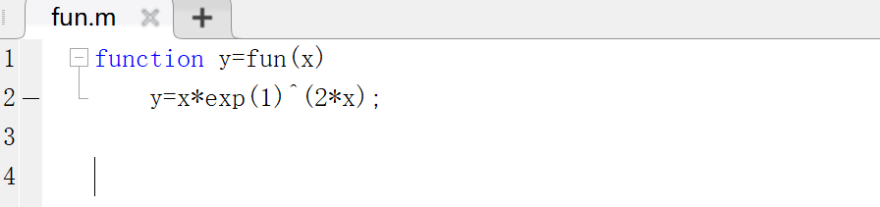

Result table

